**UNIVERSITY-BANGLADESH**

Choose an item.

**Lab Report Sheet**

|  |  |  |  |  |
| --- | --- | --- | --- | --- |
| Experiment Title: | Familiarization with microcontroller, study of blink test using and implementation of a traffic control system using microcontrollers | | | |
| Experiment No: | 2 | | Date of Submission: | 15 February 2022 |
| Course Title: | Microprocessor And Embedded Systems | | | |
| Course Code: | 00499 | | Section: | F |
| Semester: | Spring | 2021-22 | Course Teacher: | Dr. Nadia Anam |

**Declaration and Statement of Authorship:**

1. I/we hold a copy of this Assignment/Case-Study, which can be produced if the original is lost/damaged.
2. This Assignment/Case-Study is my/our original work and no part of it has been copied from any other student’s work or from any other source except where due acknowledgement is made.
3. No part of this Assignment/Case-Study has been written for me/us by any other person except where such collaborationhas been authorized by the concerned teacher and is clearly acknowledged in the assignment.
4. I/we have not previously submitted or currently submitting this work for any other course/unit.
5. This work may be reproduced, communicated, compared and archived for the purpose of detecting plagiarism.
6. I/we give permission for a copy of my/our marked work to be retained by the Faculty for review and comparison, including review by external examiners.
7. I/we understand thatPlagiarism is the presentation of the work, idea or creation of another person as though it is your own. It is a formofcheatingandisaveryseriousacademicoffencethatmayleadtoexpulsionfromtheUniversity. Plagiarized material can be drawn from, and presented in, written, graphic and visual form, including electronic data, and oral presentations. Plagiarism occurs when the origin of them arterial used is not appropriately cited.
8. I/we also understand that enabling plagiarism is the act of assisting or allowing another person to plagiarize or to copy my/our work.

*\* Student(s) must complete all details except the faculty use part.*

** Please submit all assignments to your course teacher or the office of the concerned teacher.

|  |  |
| --- | --- |
| Group Name/No.: | 7 |

|  |  |  |  |  |
| --- | --- | --- | --- | --- |
| **No** | **Name** | **ID** | **Program** | **Signature** |
| 1 | Adety Sarkar | 19-41653-3 | BSc [CSE] |  |
| 2 | Sheikh Talha Jubayer Rahman | 19-41468-3 | BSc [CSE] |  |
| 3 | Abid Hassan Emon | 19-41207-2 | BSc [CSE] |  |
| 4 | MD Kamrujjaman | 19-40665-1 | BSc [CSE] |  |
| 5 | Mazharul Islam | 18-37368-1 | BSc [CSE] |  |
| 6 |  |  | **Choose an item.** |  |
| 7 |  |  | **Choose an item.** |  |
| 8 |  |  | **Choose an item.** |  |
| 9 |  |  | **Choose an item.** |  |
| 10 |  |  | **Choose an item.** |  |

|  |  |  |
| --- | --- | --- |
| ***Faculty use only*** | | |
| FACULTYCOMMENTS | **Marks Obtained** |  |
|  |
|  |
|  | **Total Marks** |  |
|  |

**Title:** Familiarization with microcontroller, study of blink test using and implementation of a  
traffic control system using microcontrollers.

**Introduction:**The objective of this experiment is to get familiarized with Microcontroller. Learning to make the LED blink using Arduino and the delay functions  
€ Implementation of a traffic control system using Arduino.

**Theory and Methodology:**

Interactive electronics projects are created using Arduino which is an open-source platform. Arduino consists of both a programmable microcontroller and a piece of software, or IDE (Integrated Development Environment) that runs on your computer, used to write and upload computer code to the microcontroller board. Arduino Uno also doesn’t need a hardware circuit  
to load a new code into the board. We can easily load a C++ code into the board just using a USB cable and the Arduino IDE.

**Arduino-Family:**Arduino makes several different boards, each with different capabilities. In addition, part of  
being open-source hardware means that others can modify and produce derivatives of  
Arduino boards that provide even more form factors and functionality. Here are a few options  
that are well-suited to someone new to the world of Arduino.

**Configuration & Features Arduino Uno (R3):**

The Uno is a great choice for first Arduino project. It’s got everything to get started, and nothing don’t. It has 14 digital input/output pins (of which 6 can be used as PWM outputs), 6 analog inputs, a USB connection, a power jack, a reset button and more. It provides everything needed to support the microcontroller; simply just connect it to a computer with a USB cable or power it with an AC-to-DC adapter or battery to get your work done.

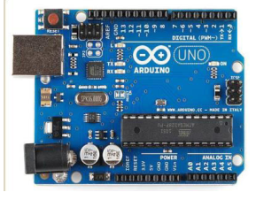

Figure 1: Arduino Uno (R3)

**Overview of the board (Arduino Uno R3):**

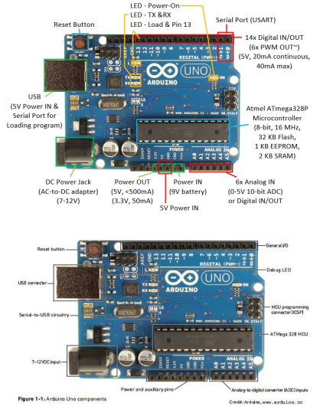

Figure 2: Arduino Uno components

Arduino Uno components List:

1. **DC Power Jack and USB connector**
2. **Pins (5V, 3.3V, GND, Analog, Digital, PWM, AREF)**
3. **Reset Button**
4. **Power LED indicator**
5. **TX RX LEDs**
6. **Main IC**
7. **Voltage Regulator**

**Apparatus:**

* Arduino IDE (any version)
* Arduino Uno (R3) board or Arduino mega 2560 board
* LED lights (RED, GREEN and YELLOW) and three 200 ohms resisters and jumper wires

**Familiarization with the Arduino Commands**In this section,  
1. We will learn about some common Arduino commands that will help write code.  
2. This section also focuses on the standard Library functions associated with the IDE.  
**a) \*\*\*\***pinMode(X, INPUT) or pinMode(X,OUTPUT) **\*\*\*\***this command will configure any pin at the Arduino board as either input/output.  
**b) \*\*\*\***digitalWrite(X, LOW) or digitalWrite(X, HIGH) **\*\*\*\***this command will provide a HIGH/LOW value to any digital output pin at the  
Arduino board .

**Setting up the Circuit** The main task of our lab is to understand and implement a traffic  
control system after understanding to blink a LED light.

**Simulation And Code:**

**Blink Test:**

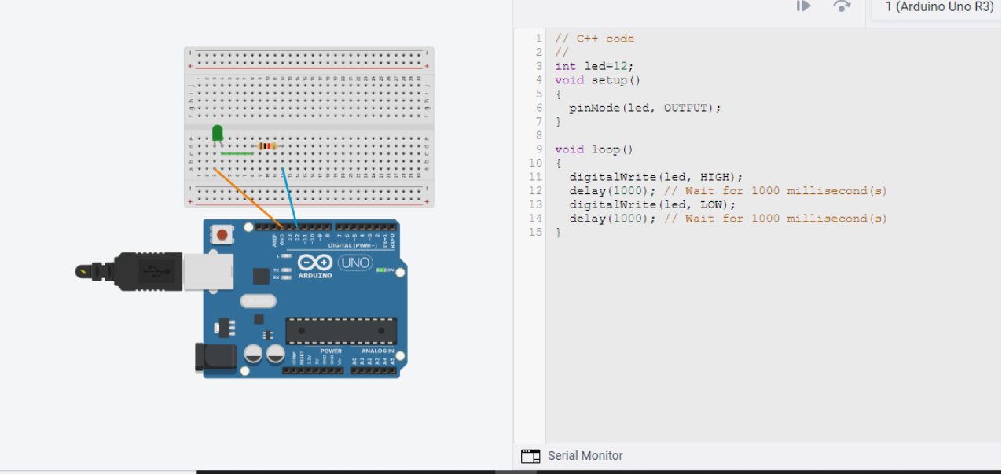

Figure 3: Blink Test Hardware

Blink Test Code:

// C++ code

int led=12;

void setup()

{

pinMode(led, OUTPUT);

}

void loop()

{

digitalWrite(led, HIGH);

delay(1000); // Wait for 1000 millisecond(s)

digitalWrite(led, LOW);

delay(1000); // Wait for 1000 millisecond(s)

}

**TRAFFIC CONTROL SYSTEM:**

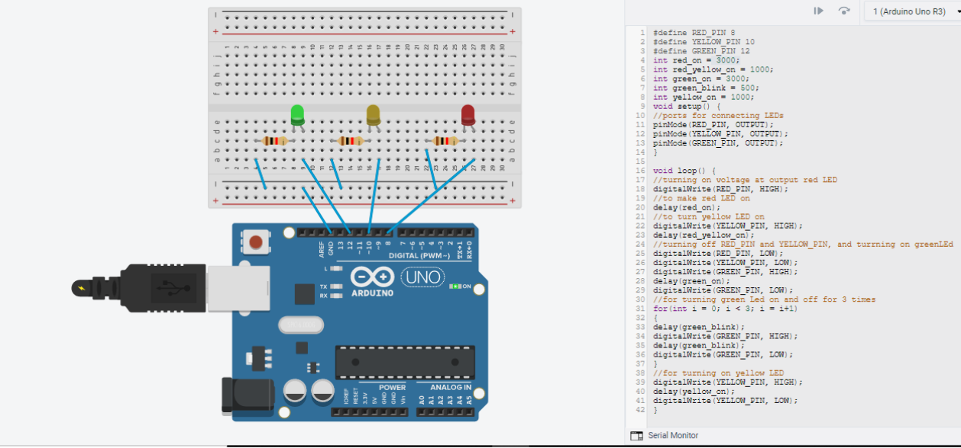

Figure 4: Hardware for traffic light

**Traffic Control System Code:**

#define RED_PIN 8  
#define YELLOW_PIN 10  
#define GREEN_PIN 12  
int red_on = 3000;  
int red_yellow_on = 1000;  
int green_on = 3000;  
int green_blink = 500;  
int yellow_on = 1000;

void setup() {  
//ports for connecting LEDs  
pinMode(RED_PIN, OUTPUT);  
pinMode(YELLOW_PIN, OUTPUT);  
pinMode(GREEN_PIN, OUTPUT);  
}  
void loop() {  
//turning on voltage at output red LED  
digitalWrite(RED_PIN, HIGH);  
//to make red LED on  
delay(red_on);  
//to turn yellow LED on  
digitalWrite(YELLOW_PIN, HIGH);  
delay(red_yellow_on);  
//turning off RED_PIN and YELLOW_PIN, and turrning on greenLEd  
digitalWrite(RED_PIN, LOW);  
digitalWrite(YELLOW_PIN, LOW);  
digitalWrite(GREEN_PIN, HIGH);  
delay(green_on);  
digitalWrite(GREEN_PIN, LOW);  
//for turning green Led on and off for 3 times  
for(int i = 0; i < 3; i = i+1)  
{  
delay(green_blink);  
digitalWrite(GREEN_PIN, HIGH);  
delay(green_blink);  
digitalWrite(GREEN_PIN, LOW);  
}  
//for turning on yellow LED  
digitalWrite(YELLOW_PIN, HIGH);  
delay(yellow_on);  
digitalWrite(YELLOW_PIN, LOW);  
}

**DISCUSSION:**

We learned how to use Arduino and the delay functions to make an LED  
blink. Initially, the system was built by a website called tinkercad.com. Then we arranged  
all the components. One Arduino Uno R3 was used for the connection of the circuit with  
1 breadboard and 3 LED resistors and 1 LED resistors. The system was controlled by code. After clicking on the run option, the simulation was successfully performed. The green light was blinking for blink test. For traffic control system the red light was initially switched on and the other two LEDs were off for 3 seconds, the yellow light was turned on for 1 seconds and the green light was switched on for 3 seconds. Following the code, the simulation ran successfully.

**REFERENCES:**

1) <https://www.arduino.cc/>.

2) <https://www.coursera.org/learn/arduino/lecture/ei4ni/1-10-first-glance-at-a-program>

3) Jeremy Blue; Exploring Arduino: Tools and Techniques for Engineering Wizardry